**Introduction**

**The background of the website**

**Why Student Union?**

Ever since we joined ITT, we knew very little about the college and things that were happening in the college. So we used this assignment as an opportunity to change this and we decided to make a website for the students in IT Tallaght .

We researched into IT Tallaght to see if they had a website for their student union. We found out that they had none so we decided to create one to help the students find out information on societies and upcoming events.

**Student Union's’ Website** :

The website is going to be an easy access for students to view upcoming events, clubs, quick announcements about their college and something that students can use to say if they want anything new in the college or if they want any changes, and they can achieve that by using our live Twitter feed service & also our facebook page.

**Analysis - user profile**

**Our target audience**:- our main target audience are the students in IT tallaght. The website is mainly for the student to view

It could also be used by people thinking of joining the college to see what sort of societies are in the college, and what sort of fun college events happen. This will help them to make a decision on whether they would like to continue their education in IT Tallaght.

**Needs and goals**:-

Purposes and objectives of the website:- The purpose of our website is to provide information for the students of IT Tallaght on the societies and upcoming events.

Our objective is to implement this purpose into our website to create a fully working website which caters for all of the students. We have a page for societies, which tells you the societies the college has which can help you to make friends and make you learning in IT Tallaght more enjoyable. We also have a what's on page which tells you all of the upcoming events that you can attend to unwind and have fun. We think that by having regular events for student to attend, they can relieve some of the stress involved with college.

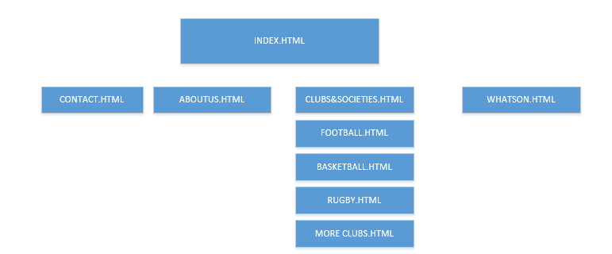

**Site Navigation**

A dynamic menu bar will be student union blue and change to a menu button on smaller window sizes. The clubs bar will drop down on hover and show the college’s top 3 sports clubs and then an option to take them to the Clubs and societies page that will show all the clubs.

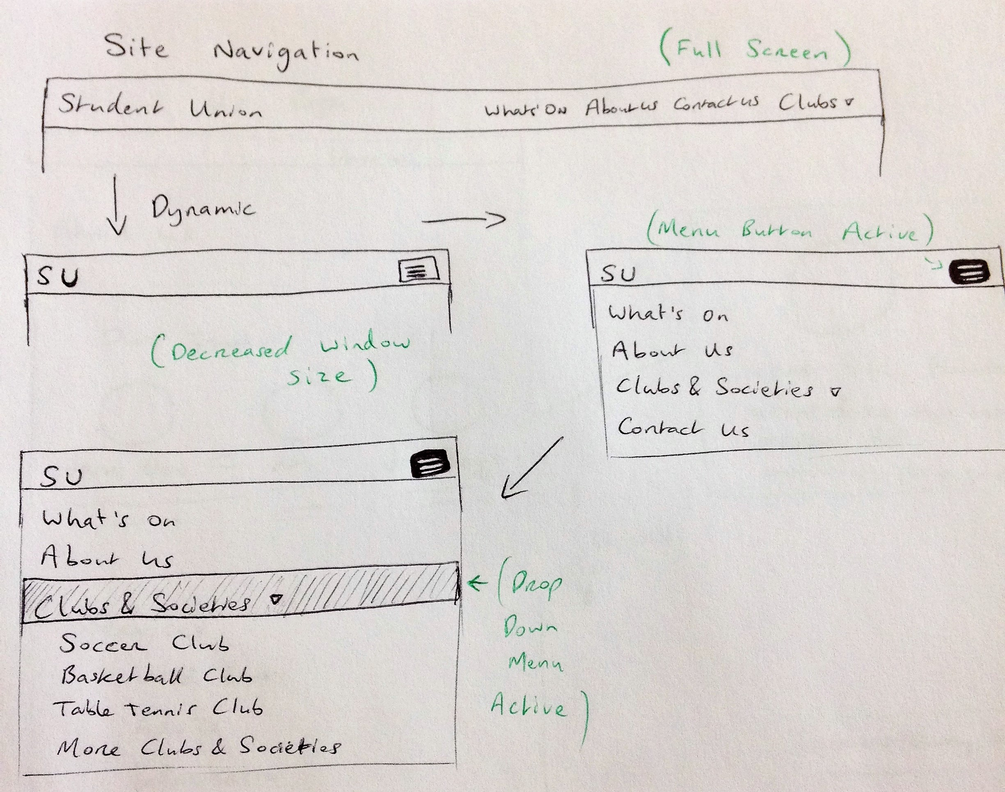

The Home Page then will consist of a slideshow and below that some containers, one of which is a smaller slideshow for events and updates that will link to that particular event on the What’s On page.

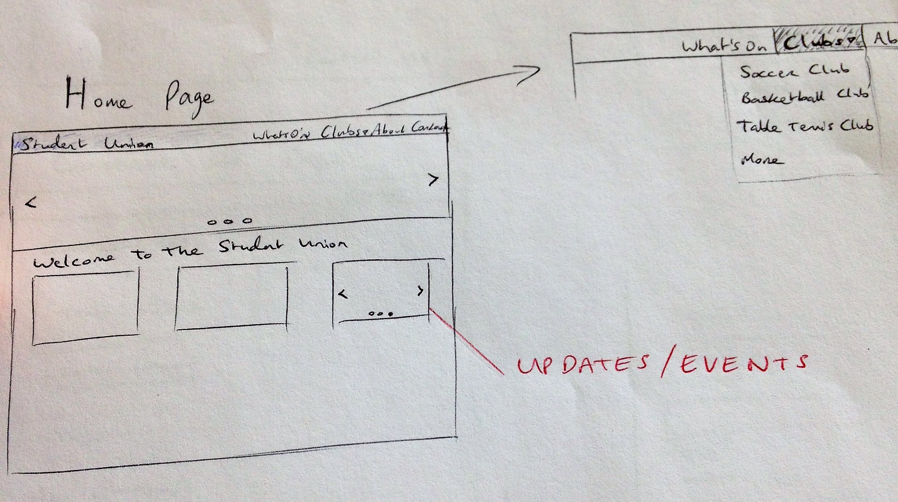

The Whats On page then will have a blog post style with a title, photo, the time and date it was posted and the content of the post. At the bottom will be previous and next buttons for older and newer posts. At the side we plan to have a live twitter feed from the Student Union’s twitter account itself.

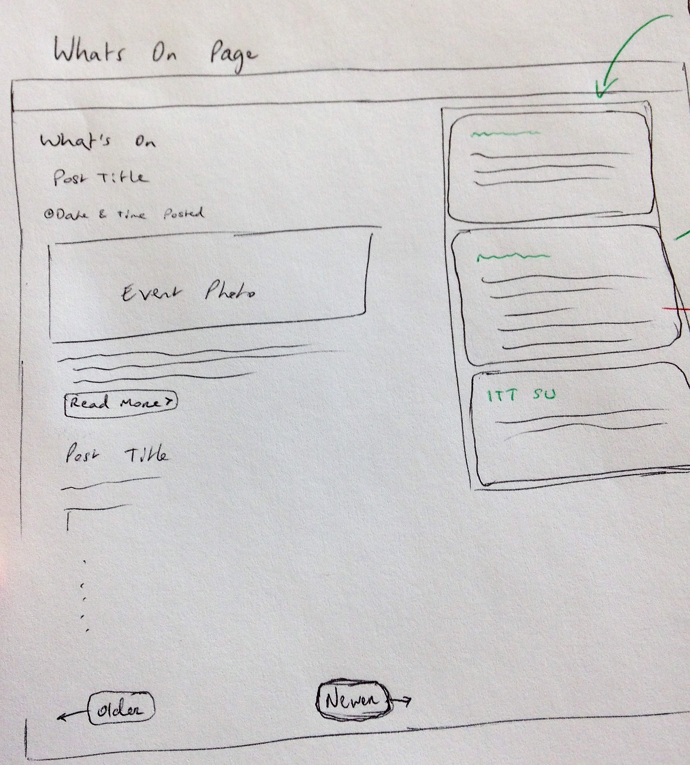Each tweet will link to the actual tweet on their twitter account. This column will show 3/4 tweets most recent tweets and when a new tweet is posted by the SU, it will come in as the top tweet and knock out the bottom tweet to keep it fresh and up to date.

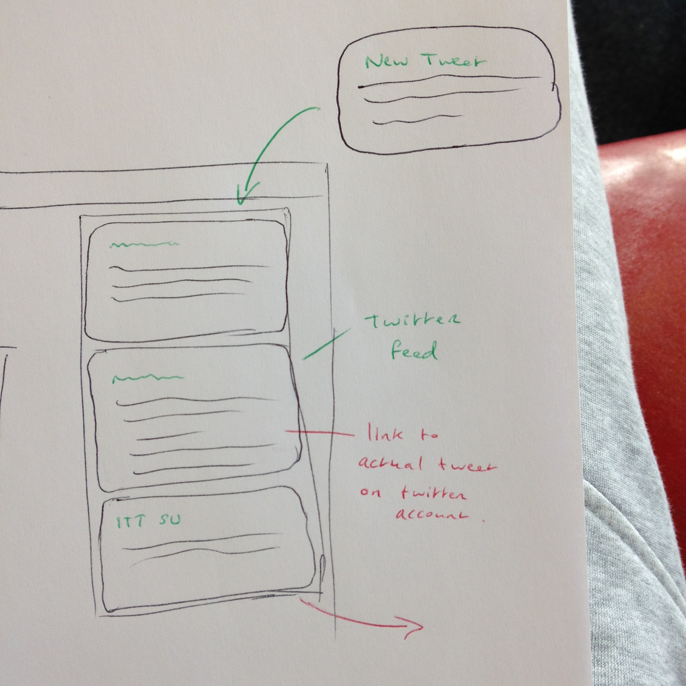

The Clubs & Societies page will show all the clubs at IT Tallaght and links to separate pages for the top 3 clubs with a team photo and contact details of the club staff. Then links to the other of these top 3 clubs pages with the same content layout.

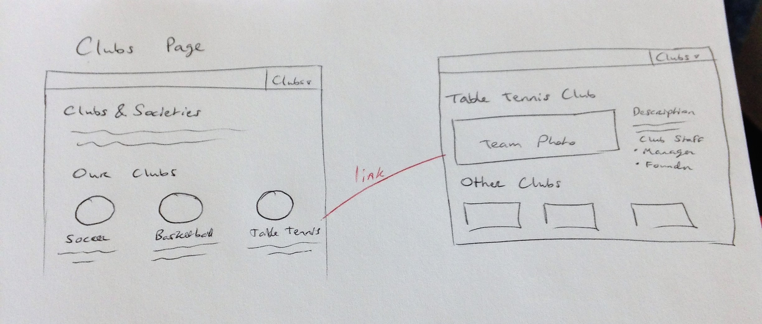

The About Us page will have a similar layout to the clubs page with photos of the staff inside circles. Then underneath will have a list of services the Student Union provide to students of ITT and a link to the Contact Page at the bottom.

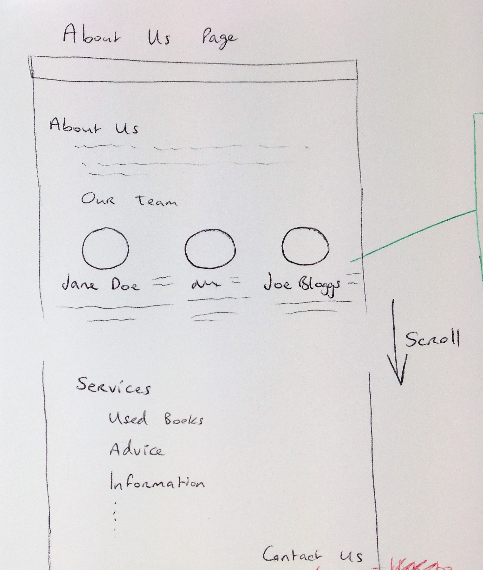

The Contact Us page will have a photo of the staff members and some content then a comment box for users to post queries.

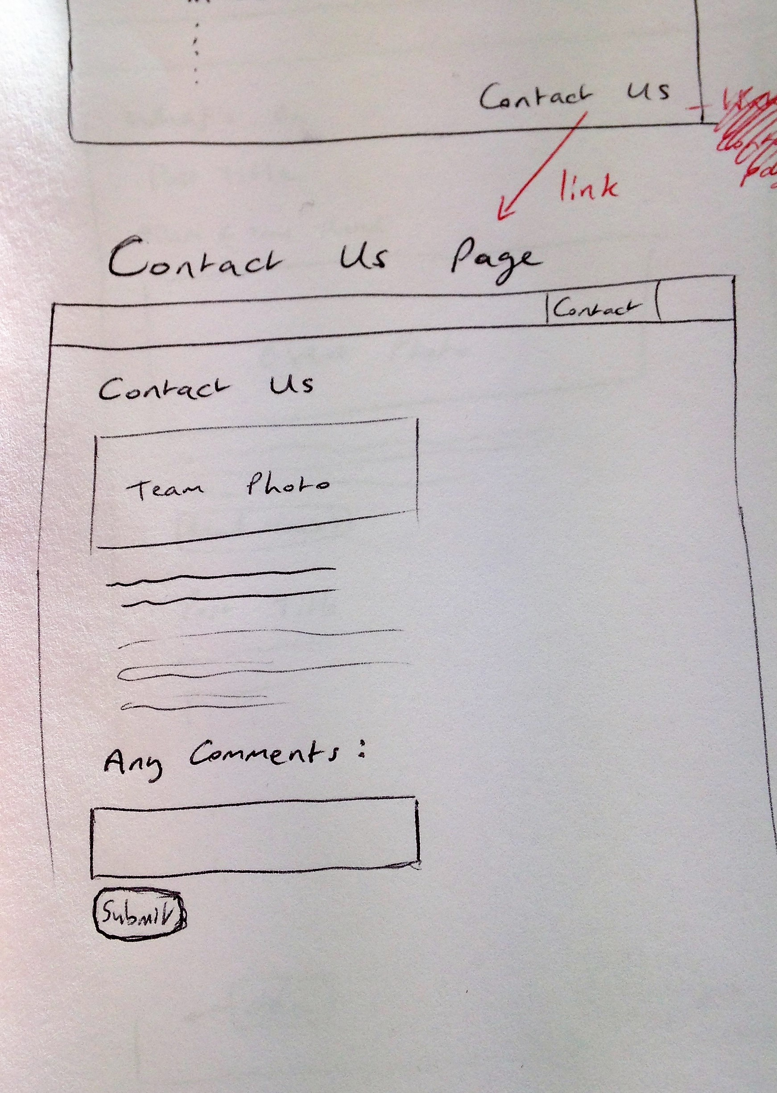 Under the comments box will be a view of the comments posted and the replies from the SU faculty members.